IEEE-HKN The Bridge Magazine
IEEE Eta Kappa Nu (IEEE-HKN) is an honor society within IEEE dedicated to encouraging and recognizing excellence in the IEEE designated fields of interest. Members consist of students, alumni, professionals and eminent scholars worldwide who have demonstrated exceptional academic and professional accomplishments.
Readers of The Bridge consist mainly of IEEE-HKN members. Of these members, the primary audience is composed of undergraduate and graduate students pursuing degrees in IEEE-designated fields of interest*. Articles should be written at a level that is accessible and relevant to the student members of HKN.
*The IEEE-designated fields are: Engineering, Computer Sciences and Information Technology, Physical Sciences, Biological and Medical Sciences, Mathematics, Technical Communications, Education, Management, and Law and Policy.

Author’s Kit for the IEEE-HKN The Bridge Magazine:
Guidelines for Pre-Submission Abstract
If you want to submit an original paper, send the following to info@hkn.org:
- Author(s) names, affiliations, telephone numbers, and E-mail addresses
- Draft Title
- Draft Abstract of 100-200 words
- Statement of Originality “This work is/will be the original work of the authors.”
- Indication of whether the draft is intended as
  - short feature
(~500-1000 words, 2-3 formatted pages with graphics included)
  - long feature
(~1000-3000 words, 3-7 formatted pages with graphics included)
- Indication of whether the draft is for a particular special issue or themed issue
- Indication of whether the submittal has been previously published in whole or in part. If so, provide a complete citation(s). Note that copyrights will likely need to be obtained for such articles to be published in The Bridge.
The Editorial Board will review the pre-submission abstract and let you know if the proposed paper is a possible fit for the magazine and will provide further instructions.

Draft Paper Review Process
After a pre-submission abstract is approved, your next step is to write and submit a draft paper. The draft paper will be peer-reviewed and you will receive suggested and required edits. You may submit a list of suggested reviewers with affiliations and contact e-mail addresses along with draft paper. A draft paper may be accepted as written, accepted with required or optional revisions, or rejected. Typically, revisions are required. An accepted draft paper will be scheduled for an upcoming issue after the required files and copyright form are received.
The initial submission should be submitted as a PDF file to info@hkn.org.
The final submission must be a WORD file for the text and separate JPEG files for each figure.

Draft Paper Guidelines
The draft paper will consist of the following
- Author(s) names, affiliations, telephone numbers, and E-mail addresses;
- Draft title;
- Abstract of 100-200 words;
- Text (~500-1000 words for short feature or ~1000-3000 words for long feature)
Suggested structure: Introduction, Main Headings (~2-4), Conclusions/Summary;
- Supporting graphics with captions;
- Appropriate references; and
- Photograph(s) and 100-word biography(ies) for each author.
A sample paper can be downloaded at
https://hkn.ieee.org/wp-content/uploads/2018/04/Article-Example-Greenslade-2013.pdf
Other information on formatting may be found at:
IEEE Style Manual
https://ieeeauthor.wpengine.com/wp-content/uploads/IEEE_Style_Manual.pdf

Evaluation Rubric
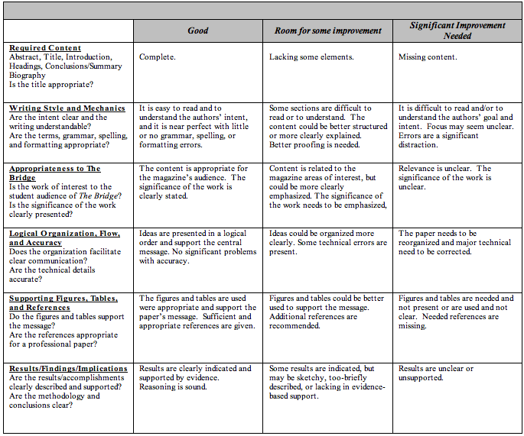

About the IEEE-HKN The Bridge Magazine:
Scope
The Bridge magazine is an archival, signature publication for IEEE-Eta Kappa Nu that highlights content with organizational, professional, technical, and career relevance to student and professional members. The magazine supports the scholarship, leadership, and service values of IEEE-Eta Kappa Nu and highlights technical achievement in, and history of, the profession. IEEE-HKN is the honor society for IEEE and includes over 200 university chapters, as well as alumni chapters.

Frequency and Distribution
The Bridge magazine is published electronically with three issues each year. It is distributed to members of IEEE-HKN, the IEEE leadership, and industry professionals.

Sahra Sedigh Sarvestani and Stephen M. Williams
Editors-in-Chief, IEEE-HKN Bridge

Dr. Sarvestani
Missouri University of Science & Technology
Electrical and Computer Engineering Department
+1 573-341-7505
sedighs@mykolab.com

Dr. Williams
Milwaukee School of Engineering
Chair, EECS
+1 414-277-7420
stephen.williams@ieee.org

Contact info@hkn.org

