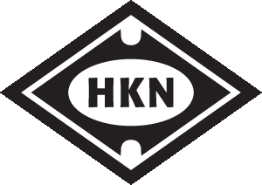

Dear IEEE-HKN Officers and Faculty

I am writing to inform you that beginning on 1 January 2018, the Board of Governors has voted to raise the induction fees for a student member to $70 per student.

This is never a decision that we take lightly, and the rates for induction have been held at their previous level for as long as we could sustain them, however as with all dues, eventually a small increase was required.

Any inductions submitted before the New Year will be processed at the current rate, and all inductions submitted in the new year will be processed at the increased rate moving forward.

Should you wish to submit an induction before the new year, please use this link and if you need any help please contact info@hkn.org

We thank you for your understanding in the need to raise these dues, and look forward to welcoming many more students into IEEE- Eta Kappa Nu in the coming years.

Sincerely,

Dr. Timothy Kurzweg,
IEEE-HKN President

